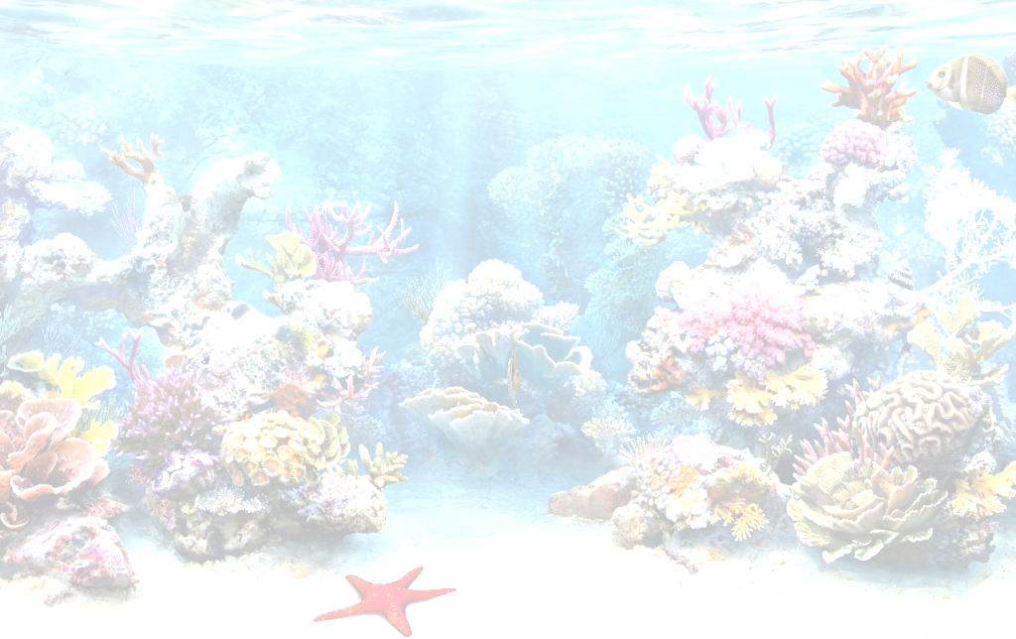
Name_______________________
Form_______________________ Model 4. Culture Corner
The Great Barrier Reef

- Think 6 new words/ phrases you have learn in this video.
1_______________________________________________________________________________________
2_______________________________________________________________________________________
3_______________________________________________________________________________________
4_______________________________________________________________________________________
5_______________________________________________________________________________________
6_______________________________________________________________________________________

- Explain the meaning of the new vocabulary.
1 waster water
2 crystal clean water
3 living organism
4 breeding ground
5 humpback
6 whales
7 natural treasure

- Complete the gaps in the text with a word derived from the words in brackets. Ex 2 a p.75

1)___________________
2)___________________
3____________________
4____________________
5)___________________
6)____________________
7)____________________
8)____________________
9)____________________
10)___________________
11)___________________
12____________________
13)____________________
14)_____________________

